Wiring ERIS A30 with U-Link 2.0 boards ( Tested – 5 wires)

- Insert the battery ONLY after all the wiring and settings have been done
- Make sure all the jumpers (the shunts) are left open, as they come from the factory
- Make sure the photocells are aligned by following the specific alignment paragraph on the full instruction
- Only remove the link between 70-72 on the control board and leave the others in place (70-71 & 70-73)
- On control boards with an LCD display, set in the Logic menu SAFE1 to 005 and press OK to confirm
- On control boards without LCD display, flick the dip-switch 3 & 4 to UP position (IO config)
and press the button S2 for more than 5sec to confirm

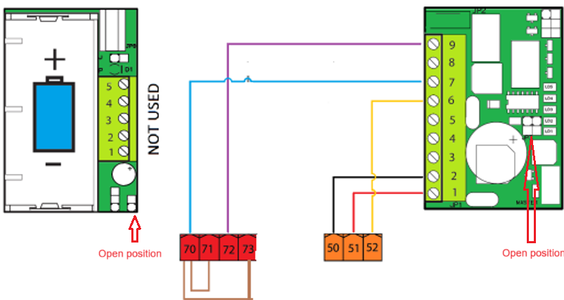
Please note that the battery side TX goes into low power mode in open position and in close position it shuts down PE beams
This wiring is Ecosol compatible

